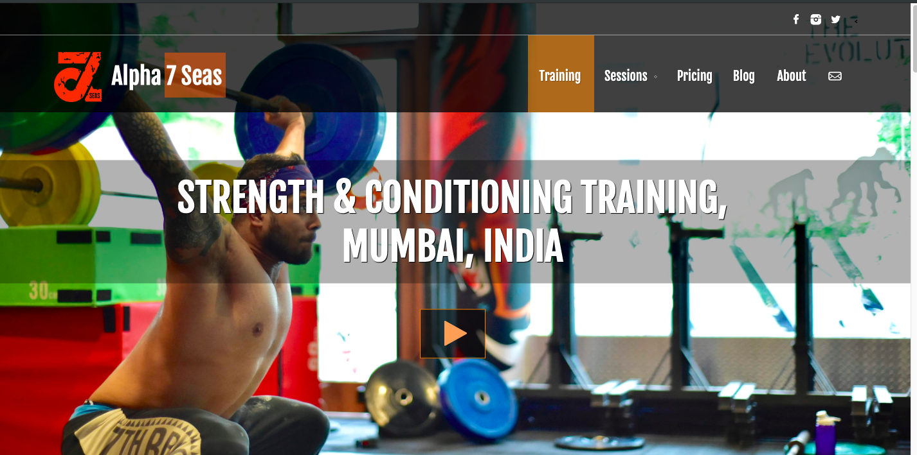

**Training Page:**

Remove the Video icon from the hero image. Also, we want to put more image in the hero section of the page.

Remove both sections from above screenshot

Put the meat in bullets after include: (refer above screenshot)

ALSO, WE NEED TO PUT VIDEOS FOR EACH REGIME UNDER STRENGTH & CONDITIONING

Guess, I have already shared the videos with you.

We need to put the pricing amount here too. Also, they want an option to change the pricing whenever they want to, here. Sign up Now is an important CTA, so please all of them in buttons. (refer below screenshot)

Remove both the sections from above screenshot.

Remove both the sections from above screesnhot.

